Contents

1- Local GIT PULL/PUSH 2

2- How to switch between different branches. 4

# Local GIT PULL/PUSH

1. **Create a folder**

(Any location will be fine; I have created under C:\Users\<username>\git\studentPractice)

1. **Go inside folder and right click on and select “Git Bash here”.**

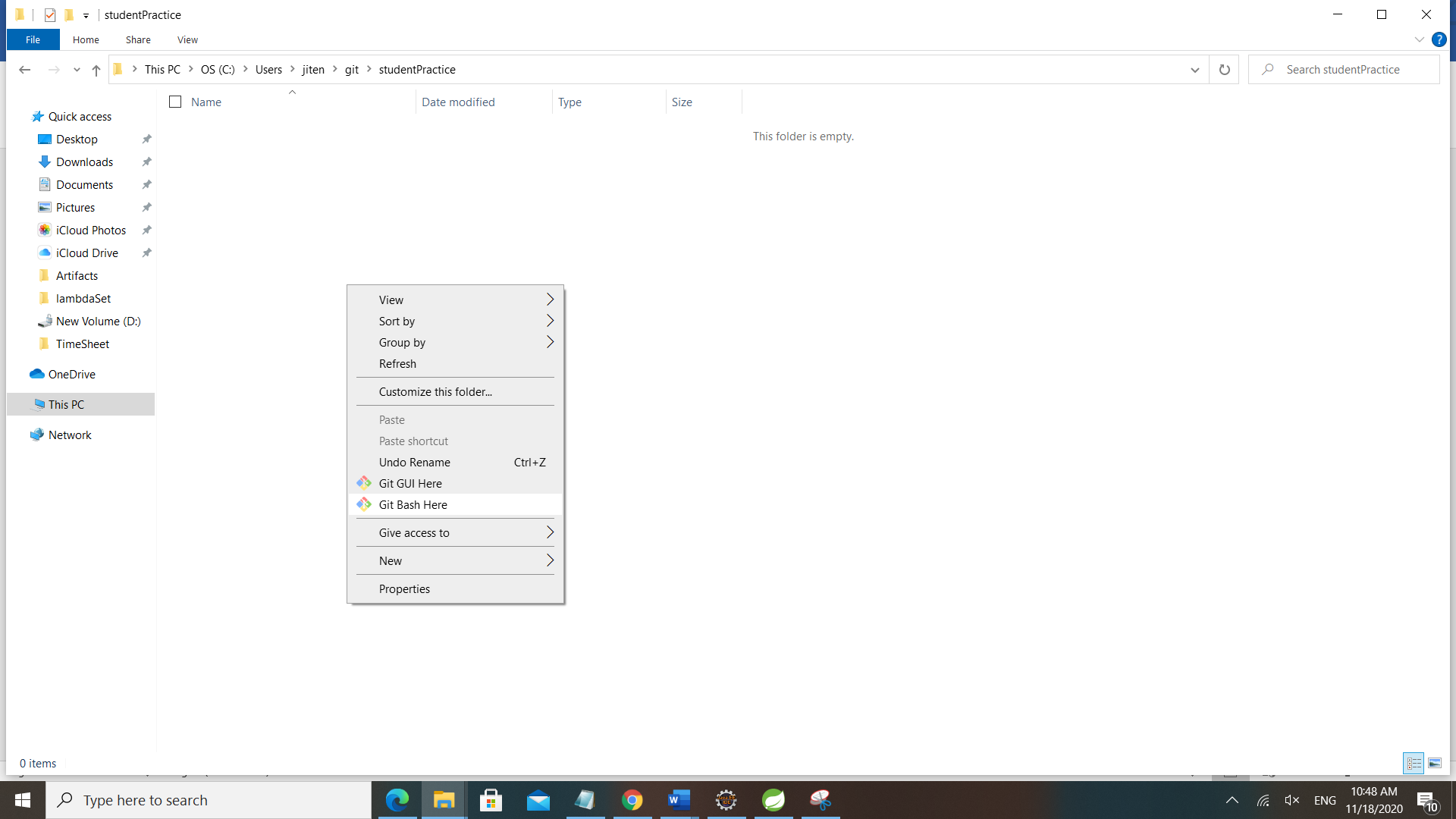

1. **Now follow these commands below**

Note :- In command 2 and 3, use your own credentials in “user.name” and “user.email”.

After these 4 steps you should able to see all the folder structure downloaded from git.

jiten@DESKTOP-R9E8DO3 MINGW64 ~/git/studentPractice (master)

$ git init

Initialized empty Git repository in C:/Users/jiten/git/studentPractice/.git/

jiten@DESKTOP-R9E8DO3 MINGW64 ~/git/studentPractice (master)

$ git config --global user.name "jstudentGit"

jiten@DESKTOP-R9E8DO3 MINGW64 ~/git/studentPractice (master)

$ git config --global user.email "jitendrakumarsamal1@gmail.com"

jiten@DESKTOP-R9E8DO3 MINGW64 ~/git/studentPractice (master)

$ git pull https://github.com/projectcarv/PracticeSet.git

remote: Enumerating objects: 134, done.

remote: Counting objects: 100% (134/134), done.

remote: Compressing objects: 100% (82/82), done.

remote: Total 259 (delta 40), reused 68 (delta 14), pack-reused 125

Receiving objects: 100% (259/259), 47.05 KiB | 1.04 MiB/s, done.

Resolving deltas: 100% (61/61), done.

From https://github.com/projectcarv/PracticeSet

* branch HEAD -> FETCH_HEAD

jiten@DESKTOP-R9E8DO3 MINGW64 ~/git/studentPractice (master)

1. **Now add java file/files to your folder. (The folder named after you)**
2. **Follow these commands.**

jiten@DESKTOP-R9E8DO3 MINGW64 ~/git/studentPractice (master)

$ git checkout master

Already on 'master'

jiten@DESKTOP-R9E8DO3 MINGW64 ~/git/studentPractice (master)

$ git status

On branch master

Untracked files:

(use "git add <file>..." to include in what will be committed)

src/com/projectcarv/praciceSet/project2021/Dharmendra/MultiplicationTable.java

nothing added to commit but untracked files present (use "git add" to track)

jiten@DESKTOP-R9E8DO3 MINGW64 ~/git/studentPractice (master)

$ git add src/com/projectcarv/praciceSet/project2021/Dharmendra/MultiplicationTable.java

jiten@DESKTOP-R9E8DO3 MINGW64 ~/git/studentPractice (master)

$ git status

On branch master

Changes to be committed:

(use "git restore --staged <file>..." to unstage)

new file: src/com/projectcarv/praciceSet/project2021/Dharmendra/MultiplicationTable.java

jiten@DESKTOP-R9E8DO3 MINGW64 ~/git/studentPractice (master)

$ git commit -m "multiplication table added to by Jitendra"

[master d5498eb] multiplication table added to by Jitendra

1 file changed, 12 insertions(+)

create mode 100644 src/com/projectcarv/praciceSet/project2021/Dharmendra/MultiplicationTable.java

jiten@DESKTOP-R9E8DO3 MINGW64 ~/git/studentPractice (master)

$ git status

On branch master

nothing to commit, working tree clean

jiten@DESKTOP-R9E8DO3 MINGW64 ~/git/studentPractice (master)

$ git remote add origin https://github.com/projectcarv/PracticeSet.git

jiten@DESKTOP-R9E8DO3 MINGW64 ~/git/studentPractice (master)

$ git push --set-upstream origin master

Enumerating objects: 16, done.

Counting objects: 100% (16/16), done.

Delta compression using up to 8 threads

Compressing objects: 100% (6/6), done.

Writing objects: 100% (9/9), 883 bytes | 441.00 KiB/s, done.

Total 9 (delta 3), reused 0 (delta 0), pack-reused 0

remote: Resolving deltas: 100% (3/3), completed with 3 local objects.

To https://github.com/projectcarv/PracticeSet.git

5a3b6a7..d5498eb master -> master

Branch 'master' set up to track remote branch 'master' from 'origin'.

1. **If you will get any error in any of these steps, you will now check in the browser you will get all the updates**

<https://github.com/projectcarv/PracticeSet/tree/master/src/com/projectcarv/praciceSet/project2021>

# 2- How to switch between different branches.

jiten@DESKTOP-R9E8DO3 MINGW64 /d/Projects/Project-2021/jitendra-git20 (testbranch)

$ git fetch

remote: Enumerating objects: 1, done.

remote: Counting objects: 100% (1/1), done.

remote: Total 1 (delta 0), reused 0 (delta 0), pack-reused 0

Unpacking objects: 100% (1/1), 632 bytes | 158.00 KiB/s, done.

From https://github.com/projectcarv/PracticeSet

* [new branch] caldev -> origin/caldev

* [new branch] master -> origin/master

jiten@DESKTOP-R9E8DO3 MINGW64 /d/Projects/Project-2021/jitendra-git20 (testbranch)

$ git branch -a

master

* testbranch

remotes/origin/caldev

remotes/origin/master

remotes/origin/testbranch

jiten@DESKTOP-R9E8DO3 MINGW64 /d/Projects/Project-2021/jitendra-git20 (testbranch)

$ git checkout caldev

Switched to a new branch 'caldev'

Branch 'caldev' set up to track remote branch 'caldev' from 'origin'.

jiten@DESKTOP-R9E8DO3 MINGW64 /d/Projects/Project-2021/jitendra-git20 (caldev)

$ git status

On branch caldev

Your branch is up to date with 'origin/caldev'.

nothing to commit, working tree clean